Django Tutorial-

Installing Django- pip install Django

Error-

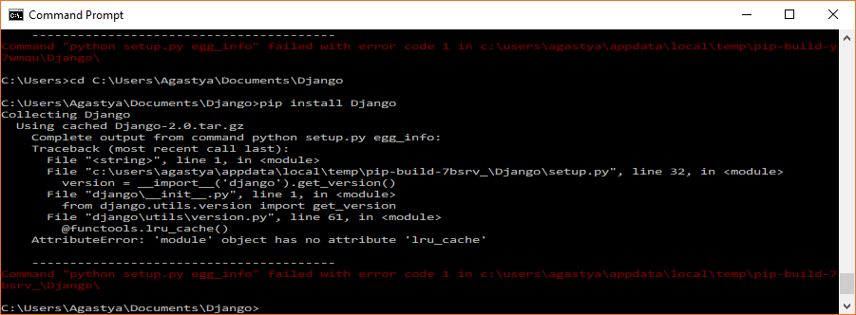

When I googled for this error message, it showed- Django needs Python 3 and does not work with the old version i.e. Python 2.7

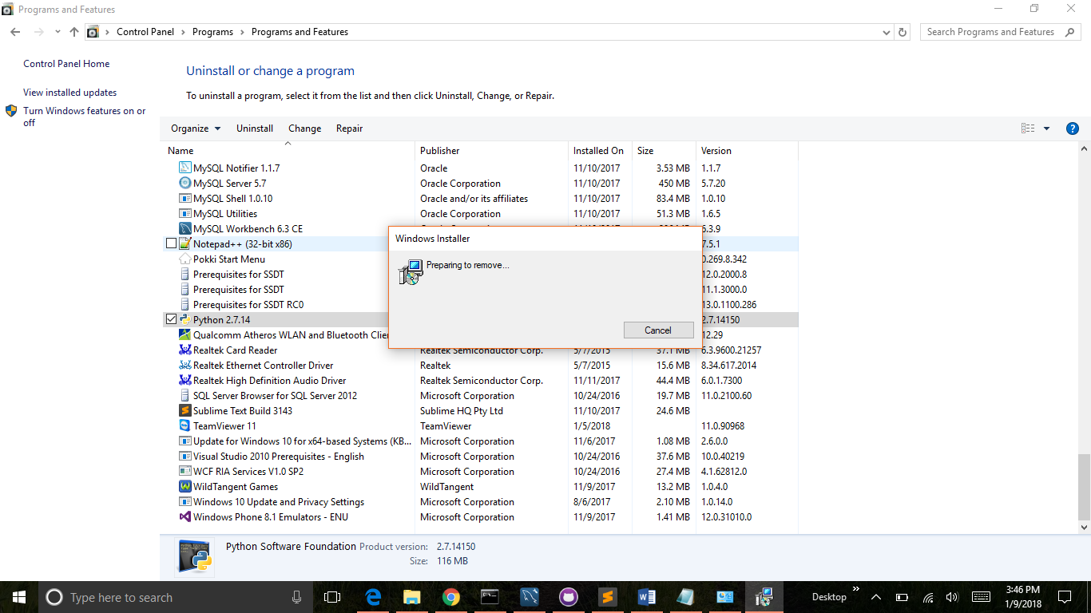

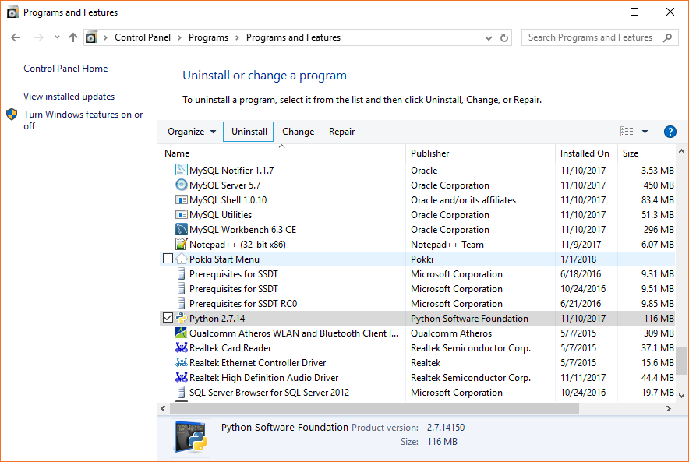

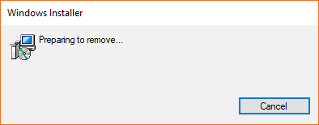

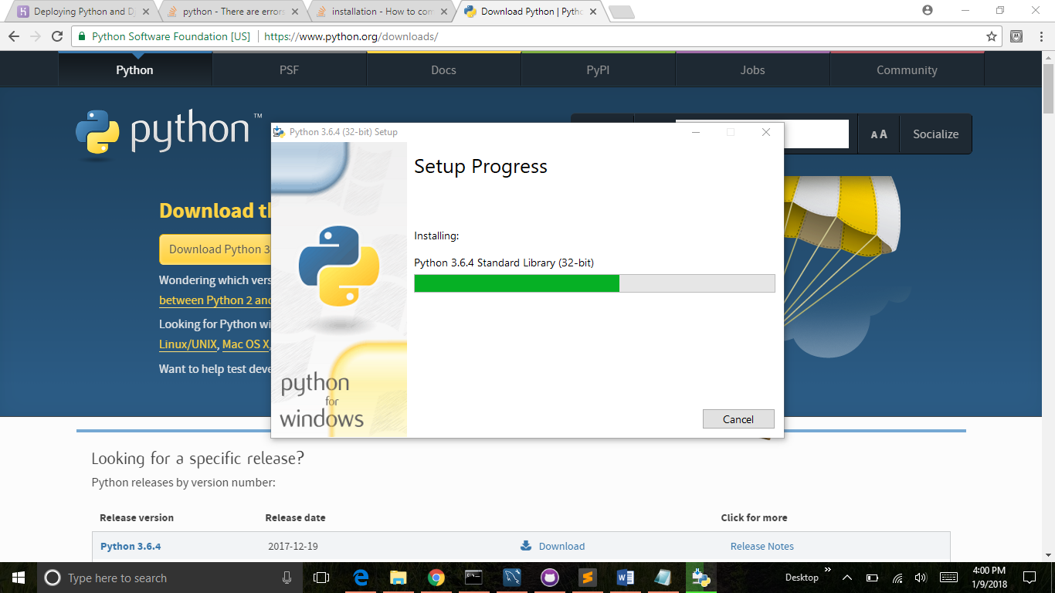

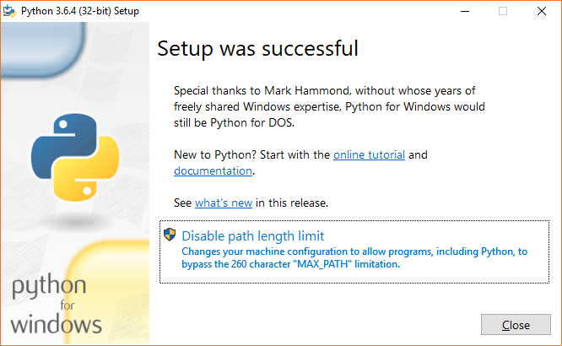

How to check if Python is Installed properly and running-

In the command prompt run the command- python

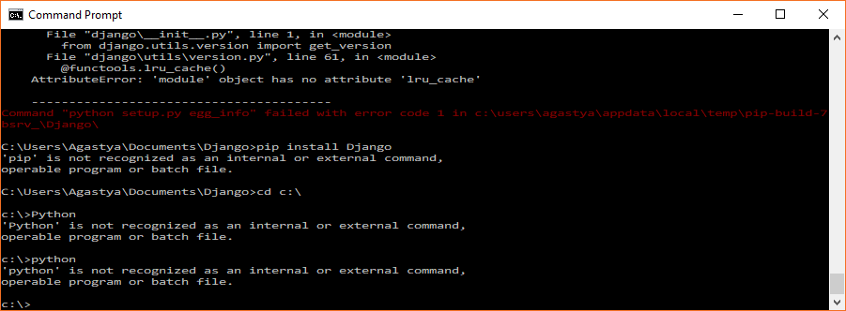

Python is not recognized. Now add Python to Path. 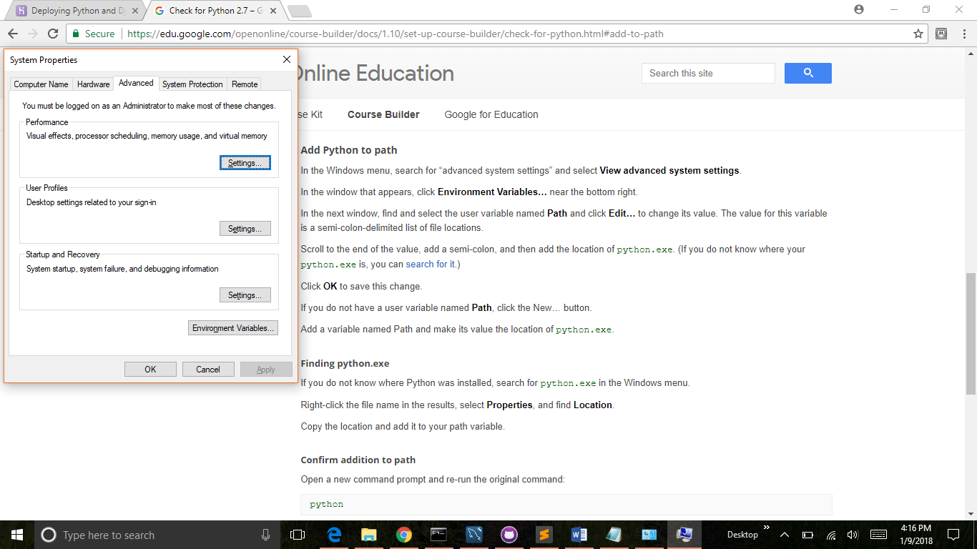

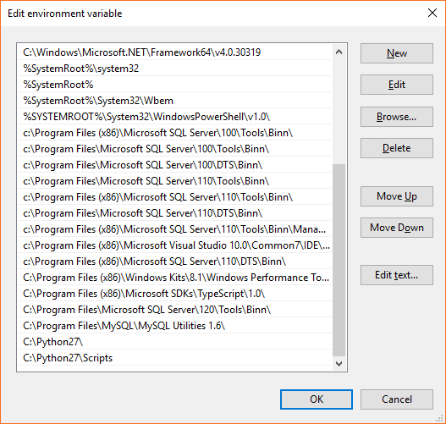

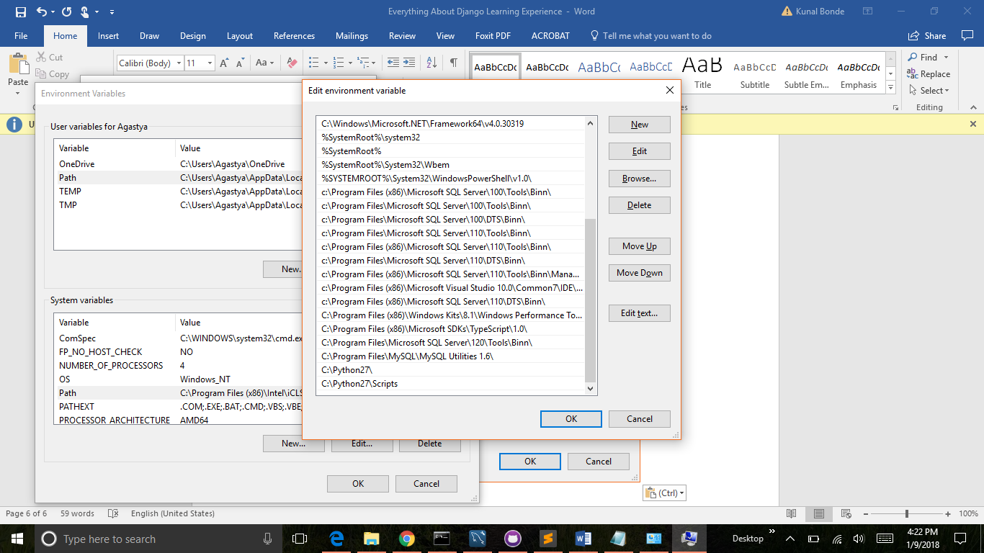

Python’s old version was uninstalled and a new version is installed successfully.

Now, time to install Django..

Pip install Django.

‘Pip’ is not recognized command. We also need to add pip to the path variable.

Now run ‘Pip install Django’ in the command prompt.

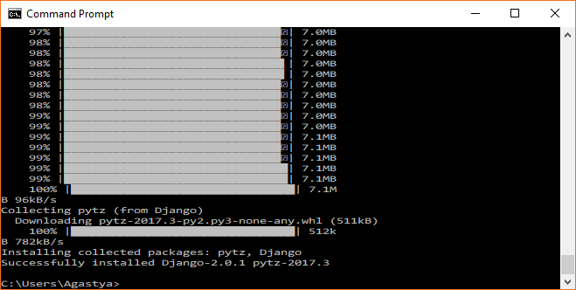

**Creating Django Project-**

Create a folder to hold the project. –Ex. Django-Tutorials.

Start a new project with a command- Django-admin startproject projectname.

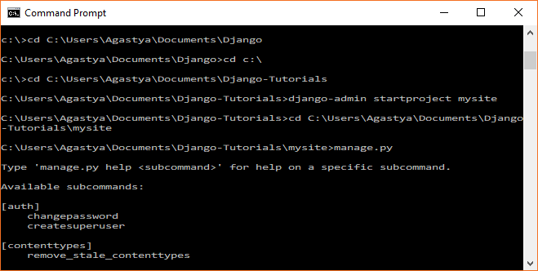

Mysite i.e. a new project will be created inside a folder Django-Tutorials.

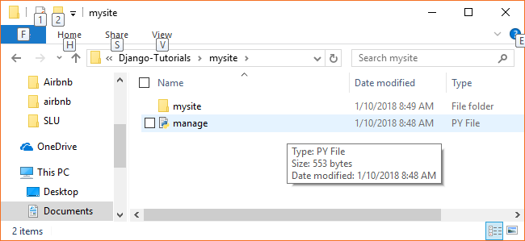

Manage- Edit with IDLE-

Open the mysite directory –

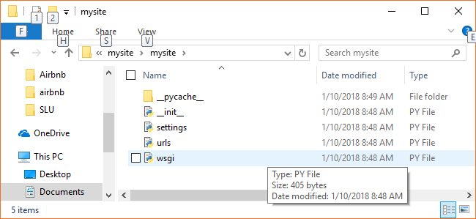

**Note:** For url, learn regular expressions-

<https://www.cheatography.com/davechild/cheat-sheets/regular-expressions/>

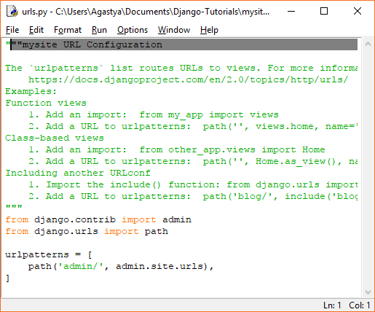

Continued Working in Django-

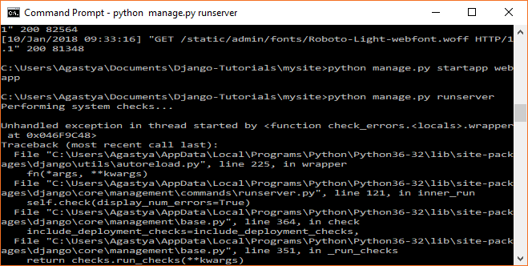

Got an error – NameError-: name ‘url’ is not defined.

I realized that it’s a Django 2 version and I am using ‘path’ instead of ‘url’ in the urls directory of mysite to specify the url. So I need to use the same in the urls directory of webapp too.

I changed the ‘url’ to ‘path’ in webapps’s urls.. and it worked as shown in the tutorials. 😊 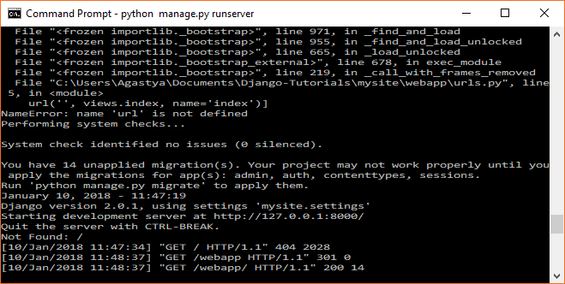

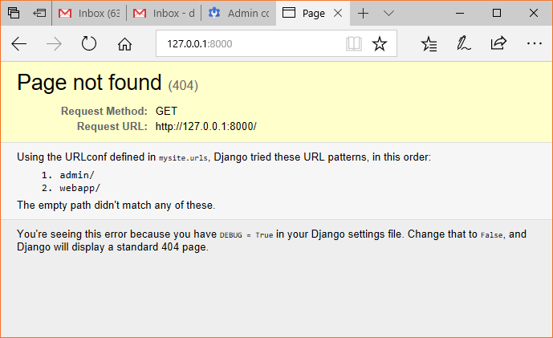

Oops.. Error ☹ But a small one. Need to specify the url..

And Hey!!!

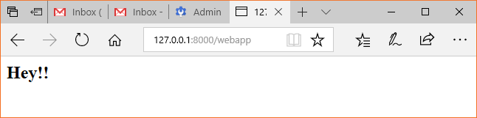

Now its time for Templates- Jinja Templates (its like master page from .net).

Jinja is the templating framework build with python.